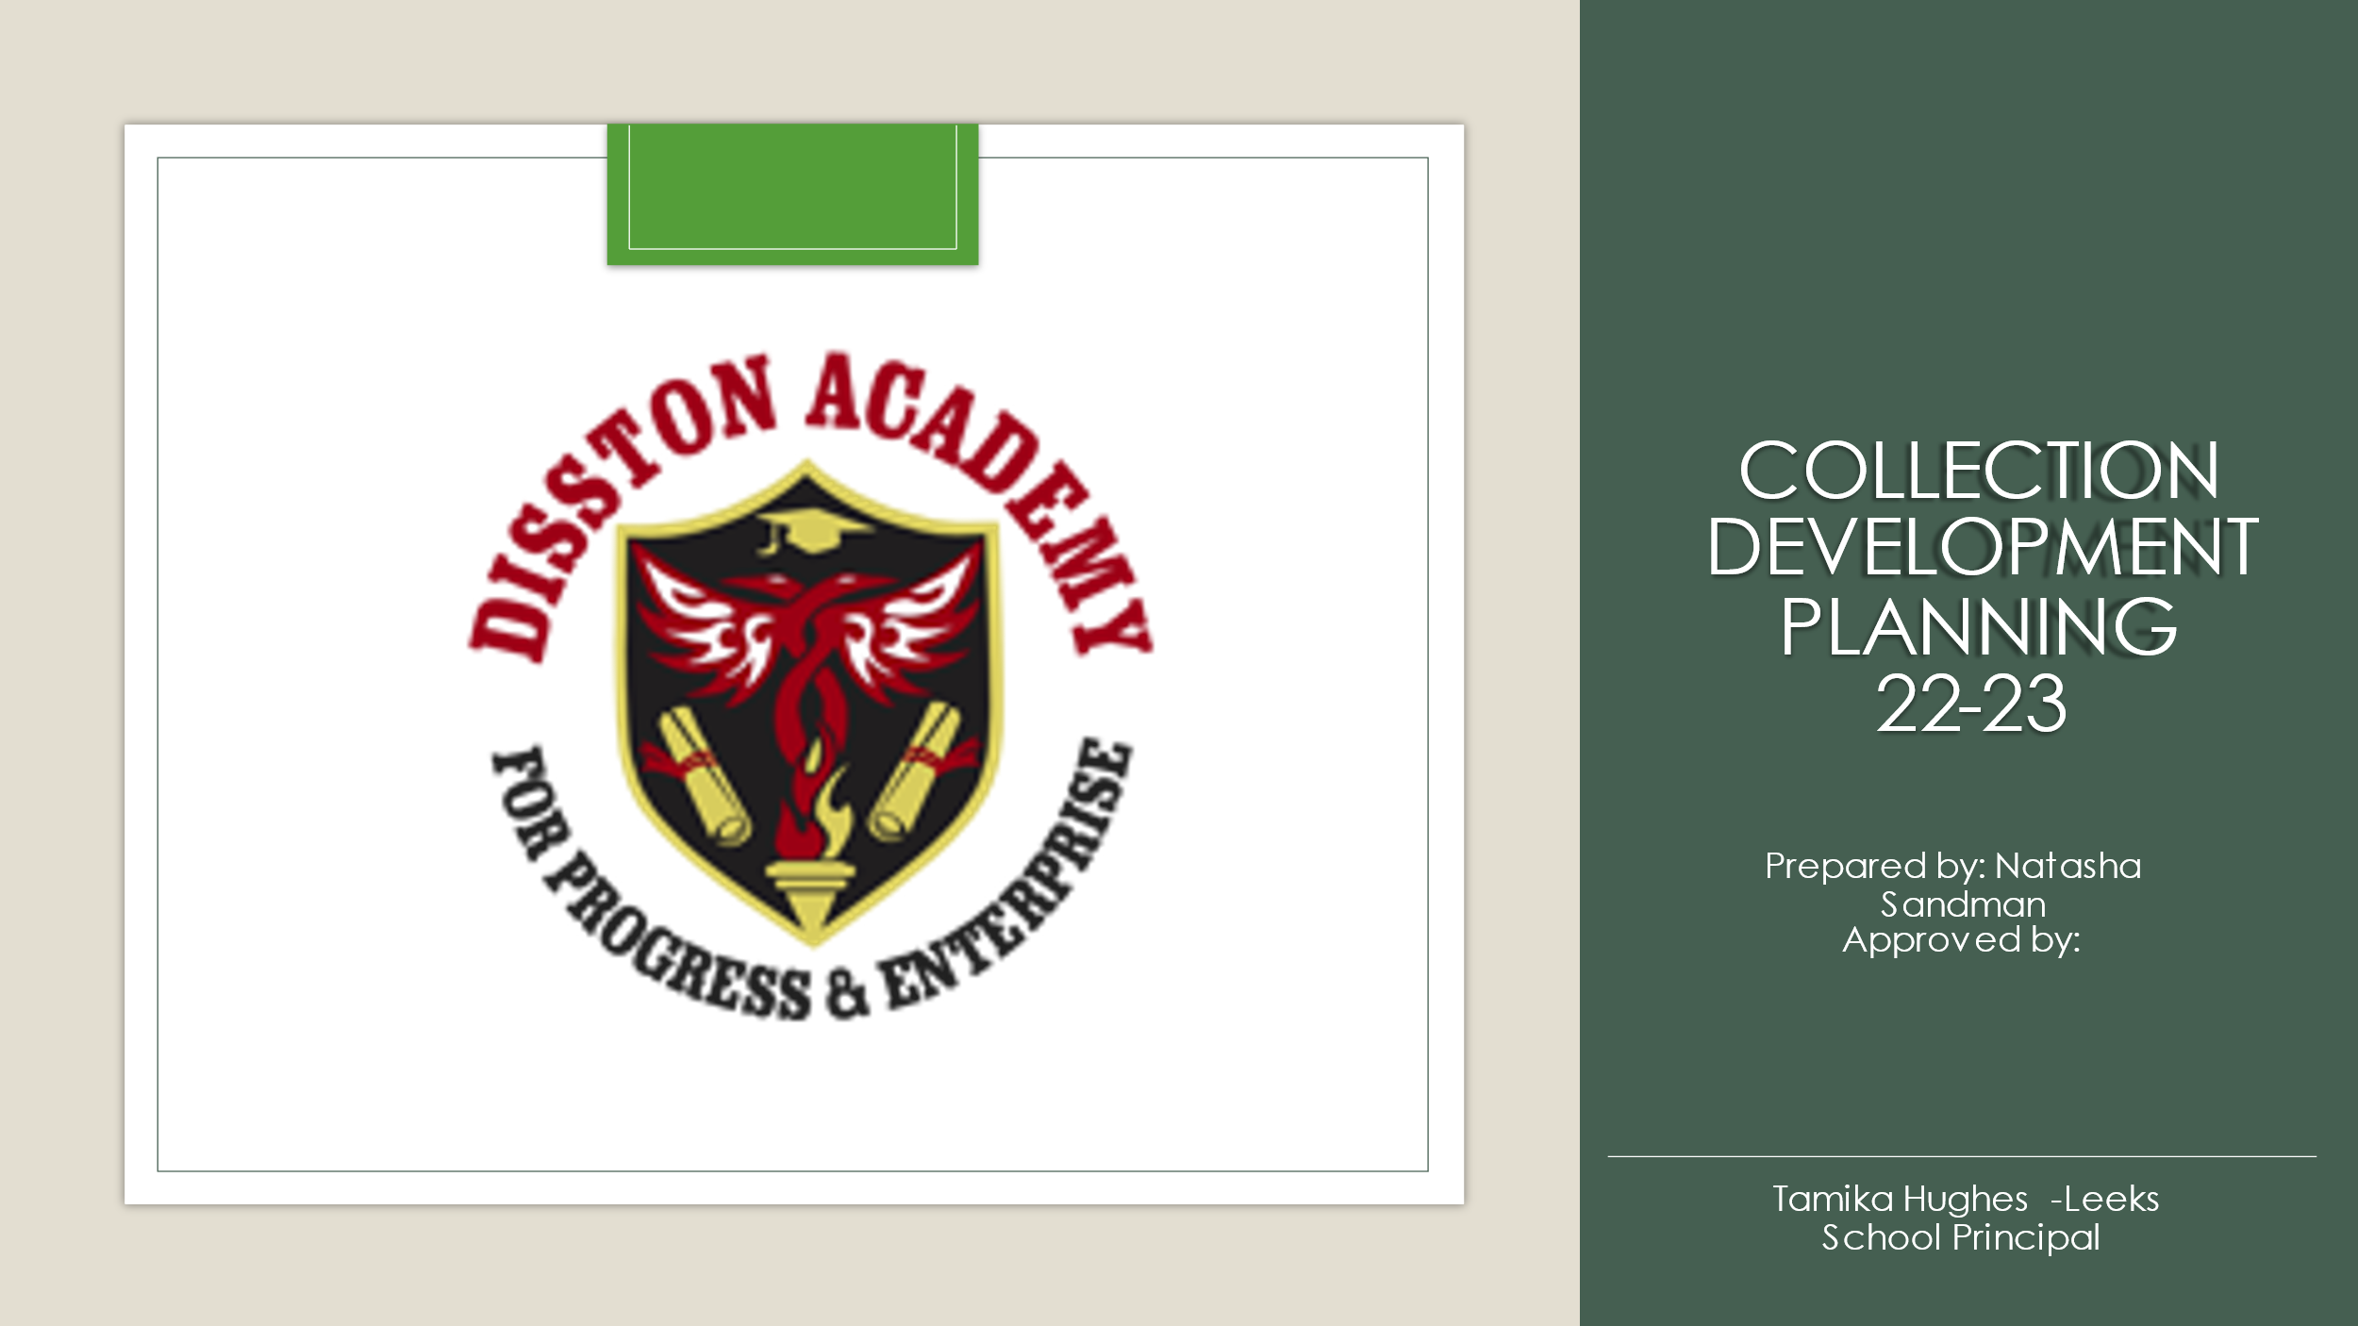

Contents

INTRODUCTION 2

LIBRARY MEDIA MATERIAL SELECTION GUIDELINES 2

GENERAL SCHOOL LIBRARY MEDIA INFORMATION 5

DIVERSITY AND INCLUSION 5

LIBRARY MEDIA COLLECTION DETAILS 5

GENERAL PRIORITIES, LIMITATIONS AND POLICIES 6

DIGITAL RESOURCE PURPOSE AND SCOPE 7

# INTRODUCTION

**School Vision: Our school vision is 100% student success through preparation, performance, and pride.**

**School Mission: Our school mission is to educate and prepare each student for college, career, and life through the expectation of performance and infusion of pride.**

**School Library Media Vision: To promote learning for all students by providing equitable access to information, teaching literacy skills and encouraging lifelong learning.**

**School Library Media Mission: To support and enhance the research, informational, reading and instructional needs of the students and staff.**

**Current Student Population Statement: FOCUS student population report**

# LIBRARY MEDIA MATERIAL SELECTION GUIDELINES

**Mission Statement**

The mission of the Pinellas County Schools Library Media Department is to support teaching and learning by providing equitable access to high quality information and technology resources, fostering a passion for lifelong reading and inquiry, and professionally managing Library Media district programs, funding and professional development.

**I. Library Media Materials and Resources Selection**

School Library Media materials and resources should be provided in both print and digital format. Materials selected should be done so with the following goals:

1. To provide age-appropriate materials and resources that appeal to the interests and curricular needs of students and faculty as outlined in the school Collection Development Plan and Florida B.E.S.T. standards;

2. To provide equitable access to materials that meet the accessibility standards consistent with Americans with Disabilities Act as needed;

3. To establish and maintain an interest in reading for all students;

4. To provide access to high quality academic resources that aid in the acquisition of information-seeking skills for all students for career and college readiness.

**II. Responsibility for Selection of Library Media Materials and Resources**

Training will be conducted annually by the Program Coordinator of Library Media and/or the Florida Department of Education regarding the prohibition of harmful materials and best practices in the selection of Library Media materials and resources per §1006.28.

Selection responsibility for District Library Media materials and resources rests with the certified Program Coordinator for Library Media.

The content of school-based Library Media collections is the responsibility of the school’s principal. The school-based selection of Library Media materials and resources rests with the school’s certified Library Media Technology Specialist. Contact information for the school Library Media Technology Specialist should be communicated to the Program Coordinator of Library Media whenever there is a change in responsibility.

The Library Media Technology Specialist will include the principal-appointed members of the school-based Library Media Selection Committee (see Form 2-2506) to assist with the selection of Library Media materials and resources at each school. This committee should also include other members such as parents and/or community members.

a. Criteria for the Selection of Library Media Materials and Resources

Library Media materials and resources are selected based on the criteria outlined in §1006.34, including, but not limited to:

1. The age of the students that are expected to have access to the material or resource;

2. The educational purpose to be served by the material;

3. Consideration of the diversity of students in this state.

Additionally, as required by §1006.40, Library Media materials should be:

1. Free of pornography and material prohibited under s. 847.012.

2. Suited to student needs and their ability to comprehend the material presented.

3. Appropriate for the grade level and age group for which the materials are used or made available.

b. Procedures for Selection of School Library Media Materials and Resources

Selection of school Library Media materials and resources is determined by a continuous review of the existing collection, both print and digital, and the acquisition of newly published or available materials. Information and training regarding the selection process and best practices will be provided annually by the Program Coordinator of Library Media.

The certified Library Media Technology Specialist is responsible for evaluating and reviewing materials in the school-based library collection. The procedure for selection is as follows:

1. Maintain the school Library Media Collection Development plan;

2. Locate and collect professional, reputable, and unbiased reviews and information about published material put forth by the American Library Association, Kirkus Reviews, School Library Journal, Common Sense Media, and other similar review sources generally accepted by the Library Media profession;

3. Request input from members of the school-based Library Media Selection committee, appointed by the principal;

4. If applicable, verify that the format and library processing of the material conforms with District Processing Specifications.

**III. Responsibility for the Withdrawal of Library Media Materials and Resources**

The removal or discontinuance of school Library Media materials and resources, through a process called weeding, is determined by a continuous review of the existing collection, both print and digital. In the removal process, many factors are taken into consideration including, but not limited to, space constraints, time-sensitivity of material, physical condition of the material, and circulation data.

The certified Library Media Technology Specialist is responsible for the periodic removal or weeding of Library Media materials. Information and training regarding the weeding process and best practices will be provided annually and as-needed by the Program Coordinator of Library Media.

**IV. Opt-Out and Review of Library Media Materials**

Parents and guardians can opt-out of student access to Library Media materials at any time by contacting their school Library Media Technology Specialist.

Parents and guardians can also view current checkouts and holds for their student at any time via Clever using the Follett Destiny Discover (My Stuff) app and Sora (Shelf) app. County residents can view school library collections by going to destiny.pcsb.org. eBook and audiobook records can also be searched through Destiny.

Parents and county residents can request Library Media materials for review by contacting the school that provides access to the material. If it is a district resource, parents and county residents should contact the Program Coordinator of Library Media. For formal objections to Library Media materials, please complete the [Objection to Instructional Material and/or Media Material form](https://www.pcsb.org/site/handlers/filedownload.ashx?moduleinstanceid=67075&dataid=119482&FileName=Objection%20for%20IMform.pdf). See complete [School Board Policy 2510](https://go.boarddocs.com/fl/pcsfl/Board.nsf/goto?open&id=BE6K2C4FBC75).

# GENERAL SCHOOL LIBRARY MEDIA INFORMATION

**Total Circulations for Previous School Year (Destiny Back Office): No existing collection**

**Current Number of Copies in Library Collection (Destiny Back Office): No existing collection**

**Library Collection Age (Titlewave): Inaugural year**

**Current School-based Library Collection General Goal(s):**

**Goal 1 Develop a media center for students consisting of physical and virtual materials for students**

**Goal 2 Assist teachers with Controversial Materials compliance**

# DIVERSITY AND INCLUSION

**Supporting District Resources:** Many of our district’s digital Library Media resources support our diversity and inclusion initiatives.

**TeachingBooks** provides supplemental resources to support teaching with texts that have themes of inclusion and represent diverse cultures and perspectives.

**Gale Databases** provide accessibility features that scaffold primary and secondary source informative text for all learners and support English Language Learners (ELL).

**World Book Online** provides accessibility features that scaffold primary and secondary source informative text for all learners and support English Language Learners (ELL).

**Large Print and Braille texts** can also be provided for scholars that can benefit from their inclusion in the Library Media collection. These text formats can also be noted in the **Collection Details** section.

**Current School-based Library Collection Diversity and Inclusion Goal(s):**

**Goal 1 Include books alternative language (Spanish) copies of popular or classic books**

**Goal 2 Select books that are diverse and reflect the population of learners**

# LIBRARY MEDIA COLLECTION DETAILS

**Present Collection Levels (Titlewave): No existing collection**

**Special Collections: (document any other locations where book are held that are maintained/cataloged and what they include- class sets, book circle, ‘on your honor’, for example) none at this time**

**Other Collections: (document items that are specifically utilized at your school- large print, Braille materials, language specific, program/course specific, etc.) not at this time**

# GENERAL PRIORITIES, LIMITATIONS AND POLICIES

**Formats:** **Library bound, hardcover, digital**

**Multiple Copies Policy:**

In general, multiple copies (more than 3) of any title should be avoided except for when the purpose of the material purchase is to provide duplicate copies as outlined in the School Improvement Plan, etc. Requests for use of district Library Media funds for this purpose are approved by the Program Coordinator of Library Media on a case-by-case basis.

**Languages: English, Spanish**

**Funding Sources: District allotment, Title 1 Funds**

**Complaints and Censorship:**

Parents and county residents can request Library Media materials for review by contacting the school that provides access to the material. If it is a district resource, parents and county residents should contact the Program Coordinator of Library Media. For formal objections to Library Media materials, please complete the [Objection to Instructional Material and/or Media Material form](https://www.pcsb.org/site/handlers/filedownload.ashx?moduleinstanceid=67075&dataid=119482&FileName=Objection%20for%20IMform.pdf). See complete [School Board Policy 2510](https://go.boarddocs.com/fl/pcsfl/Board.nsf/goto?open&id=BE6K2C4FBC75).

**Gifts/Donation Policy:**

Schools reserve the right to accept or deny all Library Media material donations and gifts. Any donations must be reviewed by a certified Library Media Technology Specialist before the materials can be made available and accessible to students. This should be communicated to all donors.

**Inventory and Weeding Process:**

Annually, by the last day of the school year, each school will complete an inventory of all physical library materials.

The removal or discontinuance of school Library Media materials and resources, through a process called weeding, is determined by a continuous review of the existing collection, both print and digital. In the removal process, many factors are taken into consideration including, but not limited to, space constraints, time-sensitivity of material, physical condition of the material, and circulation data.

The certified Library Media Technology Specialist is responsible for the periodic removal or weeding of Library Media materials. Information and training regarding the weeding process and best practices will be provided annually and as-needed by the Program Coordinator of Library Media.

# DIGITAL RESOURCE PURPOSE AND SCOPE

**eBooks: to be updated**

**Audiobooks: to be updated**

**Other (Read along, etc.):**